**BRAC UNIVERSITY**

A

**Department of Computer Science and Engineering**

**CSE420: Compiler Design**

**Quiz 01, Summer 2016**

**Duration: 1.00 hours, Total Marks: 30**

**Student Name:**

**Student ID:**

**Section:**

1. What do you know about the term “multi-pass compiler”? [2]
2. State the major responsibilities of Lexical analyzer and parser. [2]
3. Define Derivation and it’s types. [2]

4. Convert RE (m+n)+(n.o.m)*+(nm*)to NFA using Thompson’s Construction. [6]

1. Convert following NFA to DFA using Subset Construction method. [3]

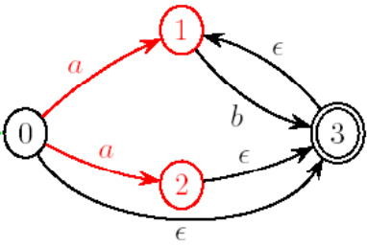

5. Convert following DFA to RE : [4]

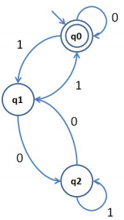

6. Draw the syntax tree of RE **(abc)(m|n*|o)\*** and determine the first-pos, last-pos, follow-pos of each node. [2+1.5+1.5+3]

7. Remove ambiguities from the following grammar: [3]

S → a S e | S T S

T → R S e | RQ

R → r S r | ε

Q → S T | ε